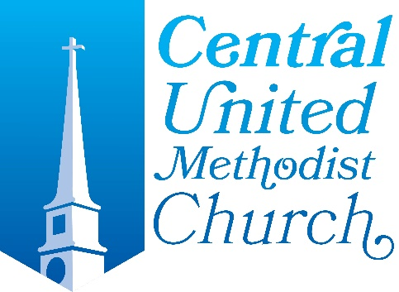
2023 Estimate of Giving

We thank you for your generous practice of stewardship. Your estimate of giving and contributions are greatly appreciated and enable Central United Methodist Church to be the hands and feet of Christ to fulfill our mission. Please complete this estimate of giving for 2023 and return via mail or on commitment Sunday, October 23, 2022.

Tithes and Offering: I/we will give a tithe of $ ____to our church 2023 Operating Budget. To be paid Weekly Monthly Quarterly Yearly
Legacy Giving: I will include the church in my will. I would like more information about planned giving.

I/We intend to give in the following manner, please check all that apply:
Cash or Check Donor-Advised Fund
Electronic giving via Realm Stock
IRA
If you need assistance or have questions about giving, please contact Patti Waldeisen, Financial Administrator @ 704-786-4109 or pwaldeisen@concordcentral.org

Name(s): ___________________________
(printed names)

Signature: _______

May we please have your current email(s) Email 1:____________________________________________

Email 2: ____________________________________________

